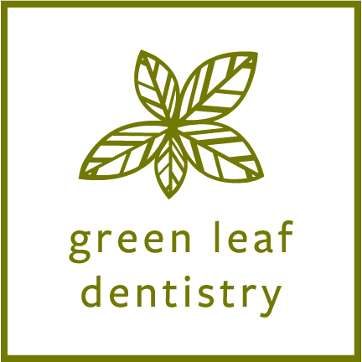

COVID-19 Pandemic Emergency Acknowledgement Form

I, _______________________________________, knowingly and willingly consent to have dental treatment completed during the COVID-19 pandemic.

I understand the COVID-19 virus has a long incubation period during which carriers of the virus may not show symptoms and still be highly contagious. It is impossible to determine who is a carrier given the current limitation in availability of virus testing.

Green Leaf Dentistry adheres to CDC mandated infection control guidelines. While every reasonable effort has been made to reduce risk of virus transmission, the risk of acquiring this virus is not eliminated. Dental procedures commonly produce aerosols and it is unclear how long these aerosols may linger in the air. While the risk appears extremely low, these aerosols can potentially transmit the COVID-19 virus.

I confirm that I currently do not have any of the following symptoms associated with COVID-19:
☐ Fever
☐ Newly Experienced Shortness of Breath
☐ Loss of Sense of Taste or Smell
☐ Dry Cough
☐ Runny Nose
☐ Sore Throat
___________ (Initial)

I understand that the CDC recommends social distancing of at least 6 feet to prevent COVID-19 transmission and this is not possible with dentistry___________ (Initial)

Signature ____________________________________ Date____________________

